**Differential Neural Correlates for Spatial Learning in Mice with Dorsal Hippocampal Lesions and Healthy Controls**

Marishka Mehta and Maxime Houtekamer

**Introduction**

A large body of evidence indicates that the hippocampus lays a critical role in spatial learning and memory (Moser et al., 1993). More specifically, it has been shown that pyramidal cells in hippocampus of rats are activated for specific locations in their spatial environment, suggesting that these neurons maintain memory of spatial information (Quirk et al, 1990). Furthermore, it has been shown that rats with a lesioned hippocampus show impaired acquisition of behavioral tasks that depend on spatial strategies, such as the Morris water maze (Morris et al., 1982). Within the hippocampus, a distinction can be made between the dorsal and ventral hippocampus, as the dorsal hippocampus receives fibers from the entorhinal cortex, while the ventral hippocampus receives projections from more medial cells (Insausti et al. 1987). The ventral and dorsal hippocampus have also been shown to contribute to different subtypes of memory. In particular, dorsal hippocampal lesions have been shown to cause impairment in spatial learning tasks (Moser et al., 1993).

In the current study, we will investigate the effect of dorsal hippocampal lesions on the acquisition rate of a spatial learning task in mice. As it is expected that the acquisition rate is decreased in lesioned mice, the duration of training will be varied, in order to investigate whether lesioned mice are able to recruit alternative brain areas in order to compensate their performance. We hypothesize lesion influences learning negatively in the first days of trial. Regarding the differential activation of structures after a variable training length, we hypothesize that there may both be recruitment of different and the same brain areas. Lastly, we hypothesize that there may be a correlation between the activation of certain structures and performance.

**Methods**

*Subjects.* A total of 90 mice were housed in transparent cages with food and water available ad libitum. They were randomly assigned to a dorsal hippocampal lesion surgery (n=48) or sham surgery (n=42).

*Behavioral testing*. In each group, the mice were furthermore randomly assigned to a 3-or 5-day training in the Morris water maze (n=848 and n=42 respectively). Each day, the mice were given one trial in the Morris water maze, and the time needed to reach the platform was recorded.

*Histology.* On the last day of training, the mice were sacrificed immediately after the training session. The brains were removed and stored in formaldehyde. Frozen sections (50 µm) were cut coronally for 19 structures of interest and stained for zif immunopositive cells. The total number of zif immnopositive cells in each structure of interest was recorded.

*Statistical procedures.* All analysis was carried out in R Studio version 0.99.489 for windows.

In order to investigate whether lesion influenced learning, a repeated measures ANOVA was carried out. The assumptions of normality was considered to be met, as a majority of the cells were normally distributed (see figure 1). A post-hoc contrast was performed using one-way ANOVA's for each day. Significance levels were set at α=0.05 for the repeated measures ANOVA, and corrected using the Bonferonni correction for the post-hoc analysis.

In order to investigate which structures were differentially activated depending on the duration of training, multiple student t test were carried out in order to compare the activation of each structures in mice given a 3-day and a 5-day training. Lesioned and sham-operated animals were analyzed separately. The assumption of normality was checked using histograms and the Shapiro-Wilk test. For the structures that met the assumption of normality, a student t test for independent with Welch correction was used. For structures that did not meet the assumption of normality, a Wilcoxon test for independent samples was used. Significance levels were set at α=0.05 and corrected using the Bonferroni correction for the post-hoc analysis. For the control group, 19 t-tests were peformed and the significance level was adjusted to 0.00263 according to Bonferroni's correction. For the lesioned group, 16 t-tests were performed, and the significance level was adjusted to 0.00320 according to Bonferroni's correction.

To analyze whether activity in certain areas was correlated with performance, Pearson's correlation was used to create a correlation grid with significance levels. Performance was defined as the time needed to reach find the platform in the Morris water maze on the last day of training. The correlation coefficients were calculated both for all the groups pooled together, and for the four different groups separately. The assumptions of normality was considered to be met, as a majority of the cells were normally distributed. Significance levels were set at α=0.05.

**Results**

**Effect of Lesion on Learning**

A repeated measures ANOVA was carried out in order to study the effects the dorsal hippocampal lesion over time. The ANOVA revealed a significant effect of time (p=2e-16,F=169.998, df1=4, df2=12). This indicates that there is a significant change in the time needed to complete the task as the training progresses, i.e., the animals learn how to navigate the maze and are able to find the platform faster over time. The ANOVA furthermore indicates a significant effect of group (p=1.95e-12, F=27.11, df1=3, df2=12). This indicates that that there is a significant difference in performance between the 4 groups, which have either a lesion or a sham lesion, and either a long training or a short training. Lastly, the ANOVA reveals a significant interaction between group and time (p=0.00462, F=2.861, df1=8, df2=252). Thus, the different groups have a different learning curve over time.

A visual representation of the effect of group and time and the interaction effect can be seen in Figure X The between group tests indicated that the variable group is significant. Consequently, in the graph we see that the liens for the two groups are rather far apart. The within subject test indicates that there is a significant time effect, in other words, the groups do change other time, both groups are taking less time to complete the task over time. Moreover, the interaction of time and group is significant which means that the groups are changing over time but are changing in different ways, which means that in the graph, the lines will not be parallel.

**Differential activation of structures depending on training duration**

In the control group without lesion, the number of zif immunopositive cells in 19 structures was compared after a long or short training of 5 or 3 days respectively. (see figure X) The activation in the perirhinal cortex showed a significantly higher activation after a long training (p= 0.001358, W=93; two-sided mann-Whitney test). Furthermore, a the activation of the CA1 region of the hippocampus was found to be significantly higher after the long training (p=3.53e-05, t=-4.662, df=39.474; two sided Student t test for independent groups with Welch correction). Lastly, the CA3 region of the hippocampus showed a significantly higher activation after a long training (p=1.027e-05, t=-5.5277, df=24.487; two sided Student t test for independent groups with Welch correction). As hypothesized, there is a significantly different activation in certain brain structures depending on the training duration. More specifically, the perirhinal cortex and the CA1 and CA3 region of the hippocampus show an increased activation after a 5-day training as compared to a 3-day training.

In the lesioned animals, three areas showed a trend towards significance, (see figure X. However, as the significance level was adjusted to 0.00320 using the Bonferroni correction, these were not considered to be significant.

**Structures that are correlated with performance**

In line with our hypothesis, the activity in several brain areas shows a significant correlation with performance on the task. Performance on the task was operationalized as the time needed to find the platform in the Morris Water Maze on the final trial. As a lower time indicates a better performance, brain areas that show a negative correlation with our variable "performance" can be interpreted as structures that positively correlate with performance.

In animals that underwent a sham surgery and were given a 3-day training, a moderate negative correlation (r=-0.44 and r=0.45 respectively) was found between activity in the entorhinal cortex and performance (p=0.030,t=-2.33, df=22), and between the cingular cortex and performance (p=0.025, t=-2.40, df=22). On the other hand, a moderate positive correlation (r=0.42) was found between activation in the visual cortex and performance (p=0.043, t=-2.15, df=22). This indicates in healthy controls with a short training period, that increased activation in the entorhinal cortex and the cingular cortex are associated with improved performance on the task, whereas increased activation in the visual cortex is associated with poorer performance on the spatial navigation task task.

A different pattern was found in animals that were lesioned in the dorsal hippocampus and given a 3-day training. A moderate negative correlation (r=-0.53) was found between activity in the perirhinal cortex and performance (p=0.007, t=-2.95, df=22). This indicates that in animals with a lesion of the dorsal hippocampus and a short training, increased activation in the perirhinal cortex can improve performance on the spatial navigation task.

In the animals that underwent sham surgery and a 5-day training, a moderate positive correlation (r=0.52) was found between activity in the prelimbic cortex and performance on the task (p=0.026, t=2.46, df= 16). This indicates that in healthy mice that are given a long training, higher activity in the prelimbic area is associated with poorer performance on the task.

In the animals with a lesioned dorsal hippocampus and a 5-day training, a moderate positive correlation (r=0.42 and r=0.51 respectively) was found between the lateral dorsal striatum and performance (p=0.041, t=2.77, df=22), as well as between the medial dorsal striatum and performance (p=0.011,t=2.77, df=22). This indicates that in animals with a lesioned dorsal hippocampus and a long training, both higher activity in the lateral dorsal striatum and in the medial dorsal striatum are associated with poorer spatial navigation performance.

**Discussion and Conclusion**

In the present study, we found that

**Supporting Information**

The original datafile and the r Markdown script outlining the analysis can be found online, at [https://github.com/MHoutekamer/statsexamen](https://github.com/MHoutekamer/statsexamen%20) .

**Figures**

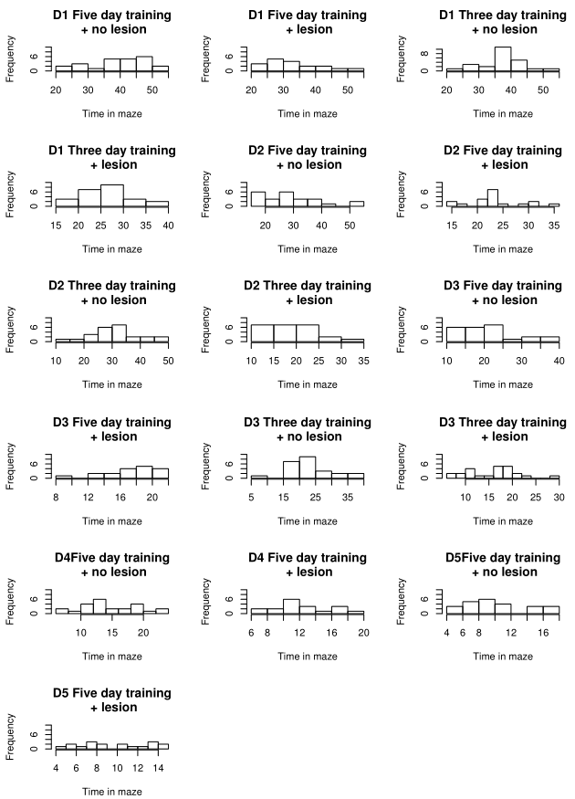

Figure 1: Histograms of time needed to find the platform in the Morris water maze, for each day of the trial. The data is shown separately for control and lesioned animals in the 3-day training and in the 5-day training.

Table 1. Overview of studied brain areas and abbreviations.

|  |  |
| --- | --- |
| **Abbreviation** | **Indicated Brain Region** |
| **STLD** | Lateral Dorsal Striatum |
| **STMD** | Medial Dorsal Striatum |
| **AMBASLAT** | Baso-lateral Amygdala |
| **AMLAT** | Lateral Amygdala |
| **ENTORH** | Entorhinal cortex |
| **PERIRH** | perirhinal cortex |
| **CA1** | CA1 of the dorsal hippocampus |
| **CA3** | CA3 of the dorsal hippocampus |
| **DG** | Dendate Gyrus, dorsal area |
| **CINGULAR** | Dcingular cortex |
| **PRELIMB** | Prelimbic cortex |
| **SOMSENS** | Somatosensorial cortex |
| **SUBICULUM** | Subiculum |
| **ACCCORE** | Corte of the Accumbens |
| **ACCSHELL** | Shell of the Accumbens |
| **VISUAL** | Visual Cortex |
| **PIRIFORM** | Piriform Cortex |
| **PARIETAL** | Parietal Cortex |
| **RETROSPLEN** | Retriospenial Cortex |

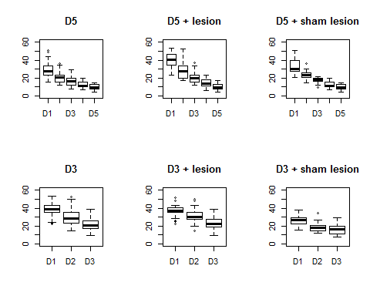

Figure 2. Box plots of task performance on each trial, for mice given a short or long training, and either a sham operation or a dorsal hippocampal lesion.

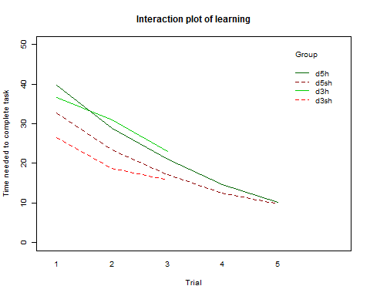

Figure 3. Interaction plot of the learning curve for a spatial navigation task. Animals with a lesion of the dorsal hippocampus are indicated in green lines, whereas control animals are indicated with a red, dotted line. The dark green and dark red lines indicate animals given a long, 5-day training. The bright red and bright green lines indicate animals given a short, 3-day training.

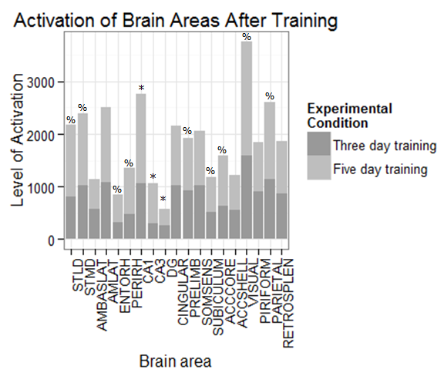

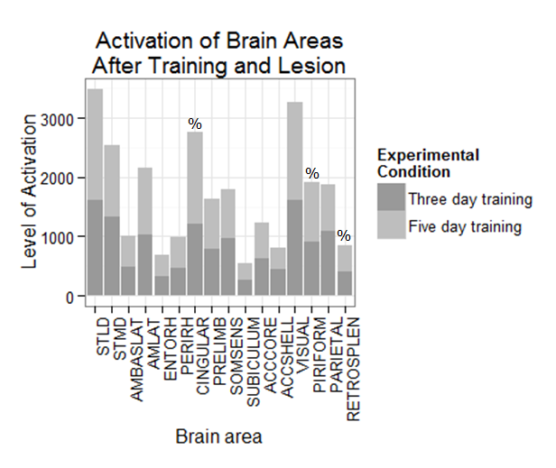

|  |  |  |  |  |  |  |  |  |  |  |
| --- | --- | --- | --- | --- | --- | --- | --- | --- | --- | --- |
|  | **Pooled** |  | **5 days, no lesion** | | **5 days, lesion** | | **3 days, no lesion** | | **3 days, lesion** | |
| **Area of interest** | **Corr** | **P value** | **Corr** | **P value** | **Corr** | **P value** | **Corr** | **P value** | **Corr** | **P value** |
|  |  |  |  |  |  |  |  |  |  |  |
| **STLD** | -0,257 | 0,015 | 0,360 | 0,143 | 0,421 | 0,041 | -0,321 | 0,126 | -0,076 | 0,723 |
| **STMD** | -0,115 | 0,282 | 0,120 | 0,636 | 0,509 | 0,011 | -0,281 | 0,183 | -0,003 | 0,990 |
| **AMBASLAT** | 0,122 | 0,252 | 0,084 | 0,742 | 0,315 | 0,134 | -0,252 | 0,234 | 0,226 | 0,289 |
| **AMLAT** | 0,035 | 0,745 | 0,204 | 0,416 | 0,153 | 0,474 | -0,219 | 0,303 | 0,246 | 0,246 |
| **ENTORH** | -0,084 | 0,431 | -0,016 | 0,950 | 0,023 | 0,917 | -0,444 | 0,030 | -0,180 | 0,401 |
| **PERIRH** | -0,066 | 0,535 | 0,123 | 0,626 | -0,029 | 0,893 | -0,303 | 0,150 | -0,532 | 0,007 |
| **CA1** | -0,298 | 0,055 | -0,069 | 0,786 |  |  | -0,145 | 0,500 |  |  |
| **CA3** | -0,304 | 0,050 | 0,202 | 0,422 |  |  | -0,106 | 0,622 |  |  |
| **DG** | -0,159 | 0,316 | 0,122 | 0,629 |  |  | 0,064 | 0,767 |  |  |
| **CINGULAR** | -0,237 | 0,025 | 0,262 | 0,294 | 0,275 | 0,193 | -0,455 | 0,025 | -0,004 | 0,985 |
| **PRELIMB** | 0,068 | 0,525 | 0,524 | 0,026 | -0,273 | 0,196 | 0,060 | 0,780 | -0,236 | 0,267 |
| **SOMSENS** | 0,097 | 0,363 | 0,395 | 0,104 | -0,006 | 0,978 | -0,223 | 0,295 | 0,206 | 0,335 |
| **SUBICULUM** | 0,241 | 0,022 | 0,354 | 0,150 | -0,186 | 0,385 | -0,361 | 0,083 | -0,110 | 0,609 |
| **ACCCORE** | -0,081 | 0,449 | 0,183 | 0,468 | 0,351 | 0,093 | -0,354 | 0,090 | 0,076 | 0,726 |
| **ACCSHELL** | -0,068 | 0,524 | 0,131 | 0,606 | 0,088 | 0,682 | -0,063 | 0,769 | 0,178 | 0,407 |
| **VISUAL** | 0,060 | 0,576 | 0,271 | 0,278 | 0,062 | 0,773 | 0,416 | 0,043 | -0,022 | 0,920 |
| **PIRIFORM** | -0,057 | 0,591 | 0,257 | 0,304 | 0,175 | 0,413 | -0,364 | 0,081 | 0,150 | 0,483 |
| **PARIETAL** | 0,068 | 0,527 | 0,384 | 0,115 | 0,292 | 0,166 | -0,293 | 0,165 | 0,237 | 0,265 |
|  |  |  |  |  |  |  |  |  |  |  |
| **RETROSPLEN** | 0,235 | 0,026 | 0,359 | 0,144 | 0,004 | 0,987 | -0,179 | 0,402 | -0,022 | 0,920 |

**References**

Insausti R, Amaral DG, Cowan WM (1987) The entorhinal cortex of the monkey. II. Cortical afferents. *J Comp Neurol* 264:356-395.

Morris RGM, Garrud P, Rawlins JNP, Q’Keefe J (1982). Place navigation impaired in rats with hippocampal lesions. *Nature* 297:68 l-683

Moser, E., Moser, M. B., & Andersen, P. (1993). Spatial learning impairment parallels the magnitude of dorsal hippocampal lesions, but is hardly present following ventral lesions. *The Journal of Neuroscience : The Official Journal of the Society for Neuroscience*, *13*(9), 3916–3925.

Quirk GJ, Muller RV, Kubie JL (1990) The firing of hippocampal place cells in the dark depends on the rat’s recent experience. *The Journal of Neuroscience : The Official Journal of the Society for Neuroscience* 10:2008-20 17.